Assignment 1 :- Create an IAM user with username of your own wish and grant administrator policy

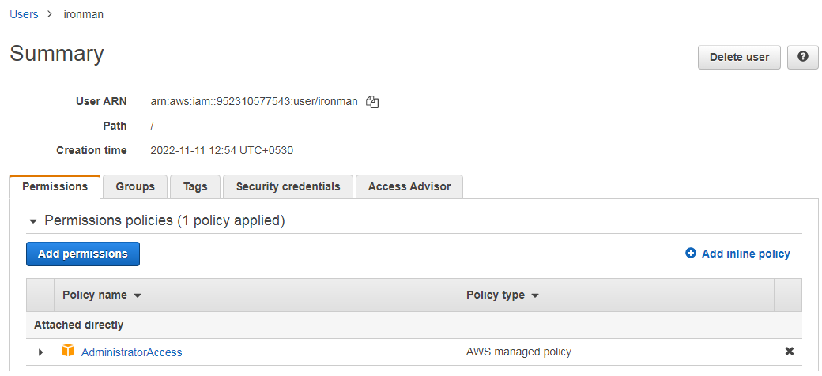

Assignment 2 :- Hello students, in this assignment you need to prepare a developers team of avengers. - Create 3 IAM users of avengers and assign them in developer’s groups with IAM policy.

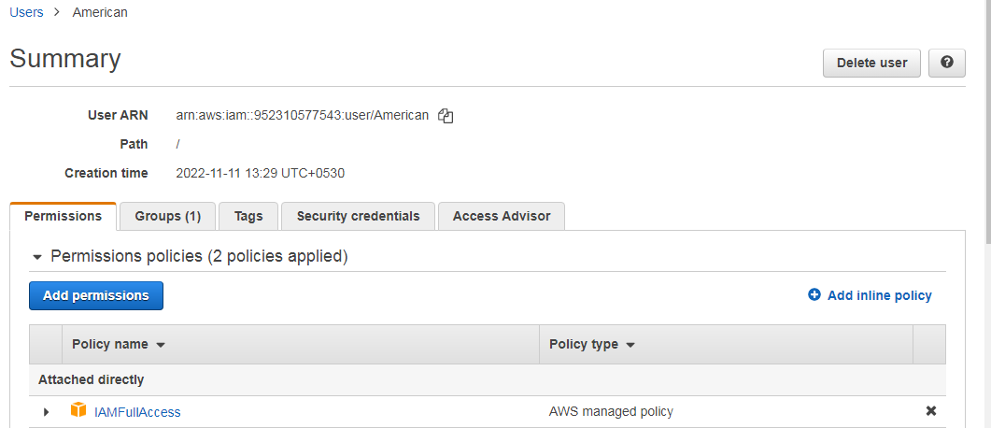

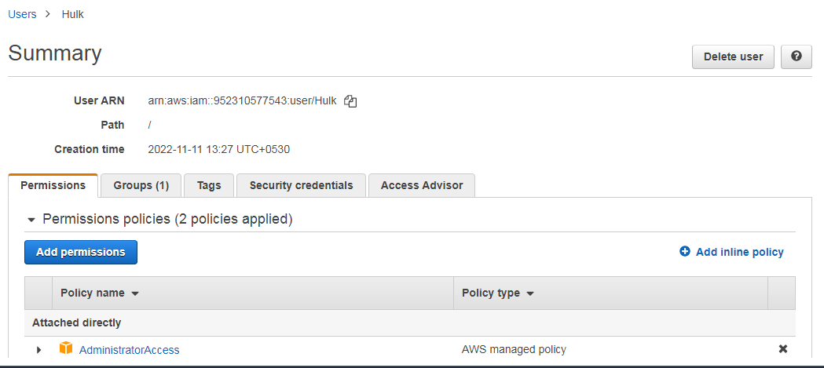

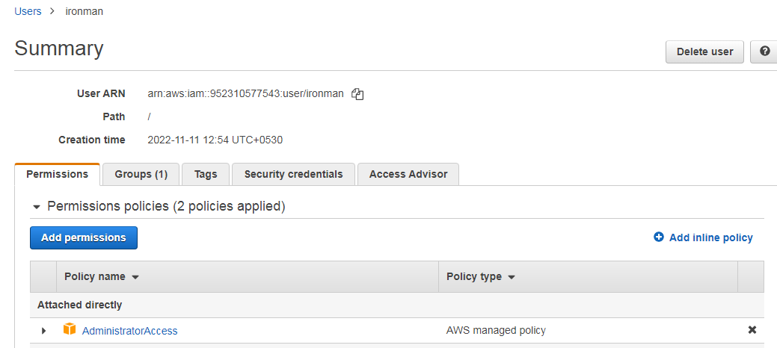

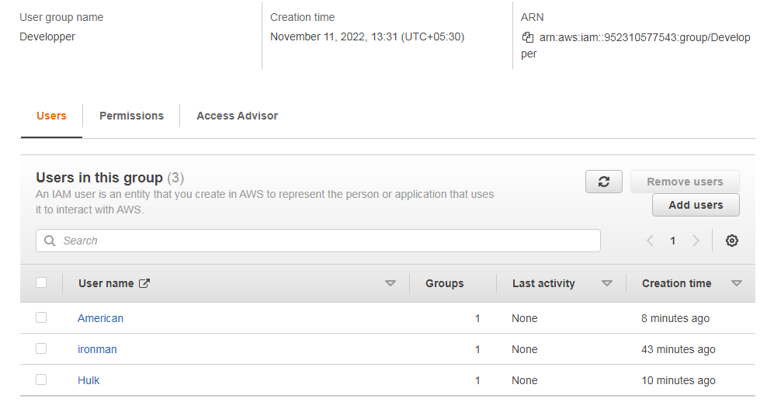

Assignment 3 :- Define a condition in policy for expiration like "DateGreaterThan": {"aws:CurrentTime": "2020-04-01T00:00:00Z"}, "DateLessThan": {"aws:CurrentTime": "2020-06-30T23:59:59Z"} Define the span of 4 months as per your wish

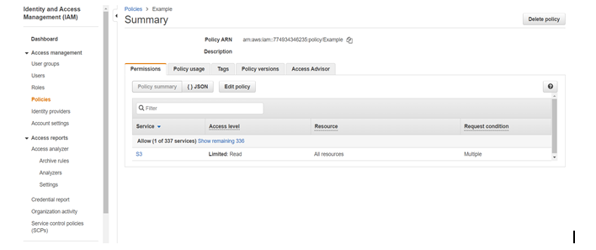

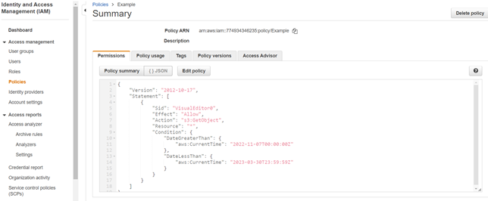

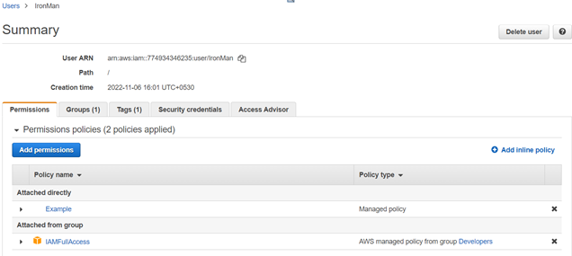

**Assignment 3 :- Prepare 15 authentic MCQ questions related to IAM.**

**1.Which of the following is not an IAM best practice?**

(a) Delete user accounts not in use

(b) Attach policies to individual users

(c) Manage permissions by adding users to groups

(d) Enable MFA on user accounts

**2. Which of these is Identity in IAM?**

|  |  |
| --- | --- |
| (a) | Users |
| (b) | Groups |
| (c) | Roles |
| (d) | All of these |

**3. An IAM user:**

|  |  |
| --- | --- |
| (a) | is an entity that you create in AWS |
| (b) | is to give people the ability to sign in to the AWS Management Console for interactive tasks and to make programmatic requests to AWS services using the API or CLI |
| (c) | A and B both |
| (d) | None of these |

**4. Which of these is IAM principal?**

|  |  |
| --- | --- |
| (a) | A user |
| (b) | A role |
| (c) | An application |
| (d) | All of these |

**5. AWS evaluates _______ when an IAM principal makes a request.**

|  |  |
| --- | --- |
| (a) | Username and Password |
| (b) | MAC Address |
| (c) | Security Policies (d) IP Address |

**6. AWS supports ______ types of policies.**

|  |  |
| --- | --- |
| (a) | 4 |
| (b) | 5 |
| (c) | 6 |
| (d) | 7   |  |  |  |  |  |  |  |  |  |  |  |  |  |  |  |  |  |  |  |  |  |  |  | | --- | --- | --- | --- | --- | --- | --- | --- | --- | --- | --- | --- | --- | --- | --- | --- | --- | --- | --- | --- | --- | --- | --- | | **7. Names of IAM identities (users, roles, and groups):**   |  |  | | --- | --- | | (a) | Must be unique within the AWS account | | (b) | Must be unique within the availability zone | | (c) | Must be unique within the region | | (d) | Must be unique within the AWS cloud whole  **8. How many maximum groups can be created in an AWS account?**   |  |  | | --- | --- | | (a) | 25 | | (b | 50 | | (c) | 100 | | (d) | 200  **9. How many maximum access keys can be assigned to an IAM user?**   |  |  | | --- | --- | | (a) | 1 | | (b) | 2 | | (c) | 3 (d) 4 | | | | |

**10.** **In addition to using IAM roles and policies or custom authorizers, you can use an ________ user pool to control who can access your API in Amazon API Gateway.**

|  |  |
| --- | --- |
| (a) | Amazon S3 |
| (b) | Amazon Cognito |
| (c) | Amazon EBS |
| (d) | All of these |

**11**. **How many maximum managed policies can be assigned to an IAM entity?**

|  |  |
| --- | --- |
| (a) | 2 |
| (b) | 5 |
| (c) | 10 |
| (d) | 20 |

**12. IAM policy documents are written in which format**

|  |  |
| --- | --- |
| (a) | XML |
| (b) | HTML |
| (c) | JSON  (d) YAML |

**13. Which of the following are managed by using IAM**

|  |  |
| --- | --- |
| (a) | Role |
| (b) | KMS |
| (c) | MFA |

(d) Security Groups

**14. Which of the following is not a component of IAM?**a. Roles  
b. Users  
c. Organizational Units  
d. Groups

**15. IAM group:**

|  |  |
| --- | --- |
| (a) | Is same as IAM users |
| (b) | Can be used to specify permissions for a collection of users |
| (c) | Is truly an identity |

(d) All of the above

**Assignment 4 :- Launch your linux instance in IAM and update your machine**

